2.2.2 Relationship between Accuracy of EFRs on Predicting Audibility of Speech Stimulus and Carriers or Frequency Groups

To explore the accuracy of EFRs on predicting audibility of each speech stimulus differ between carriers or frequency groups, we need to do some regression on the data.

We mainly consider the detectability (EFRs), which is a binary outcome, so I choose to use logistic regression since it fits the condition that response value is a binary one.

2.2.2.1 Carriers

2.2.2.1.1 Main Effect Analysis

(1) Model

We consider the following one factor regression models:



(2) Arguments and Parameters

|  |  |
| --- | --- |
| EFRs | representing the detectability of the stimulus |
| Carrier | speech sounds, which is a categorical data with 8 levels |
| Beta0 | accuracy of EFRs (detectability of the stimulus) for reference level |
| Beta(j) | difference in accuracy of EFRs (detectability of the stimulus) between j level of carrier and reference level of carrier |
| Beta0+ Beta(j) | accuracy of EFRs (detectability of the stimulus) at j level of carrier |

Table Arguments and Parameters for the Model

(3) Analysis

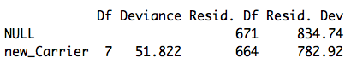

Table Anova Table for One Factor Model

Null model has a deviance of 834.74 on 671 degrees of freedom, the p-value is nearly asymptotic to 0, which doesn’t pass the goodness-of-test, so we reject the null hypothesis that all detectability is the same.

Introducing Carrier variable leads to substantial reduction of 127.29 deviance at only 7 degrees of freedom. So the variable of Carrier has significant effect on the detectability of the stimulus and accuracy of EFRs.

2.2.2.1.2 Effect of Eight Levels of Carriers on Accuracy of EFRs

In order to explore the effect of 8 levels in carriers on accuracy of EFRs, we need to fit the following model both the result of F-test and Rayleigh-test.



(1) F-test

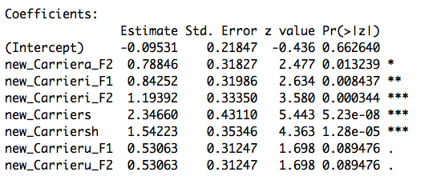

Table Model Fitting for EFRs~Carriers on F-test



Based on the result of model fitting for EFRs~Carriers on F-test above, we conclude the p-values for each 8 level in carriers so that we can judge the significance of each level in the model.

I find that all of the levels are significant at 90% confidence level. And “i_F2”, “s”, “sh” is the three most significant effects in the model.

|  |  |  |
| --- | --- | --- |
| level of carriers | Logit(pi) | pi |
| a_F1 | -0.09531 | 0.4761905 |
| u_F1 | 0.43532 | 0.6071433 |
| i_F1 | 0.74721 | 0.6785705 |
| a_F2 | 0.69315 | 0.6666673 |
| u_F2 | 0.43532 | 0.6071433 |
| i_F2 | 1.09861 | 0.7499996 |
| s | 2.25129 | 0.9047617 |
| sh | 1.44692 | 0.809524 |
| Average | / | 0.6875 |

Table Values of pi of Carriers on F-test

Based on the values of pi on F-test above, we can conclude that different levels of carriers will lead to a difference in accuracy in predicting the audibility of stimulus. The level “s” will have the highest accuracy and “a_F1” will have lowest accuracy. And the average accuracy of all levels on F-test is 0.6875.

(2) Rayleigh-test

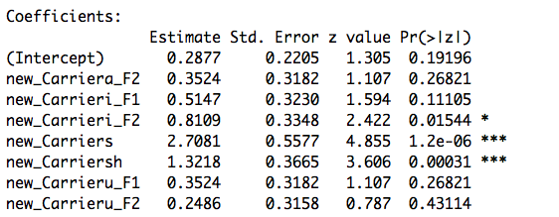

Table Model Fitting for EFRs~Carriers on Rayleigh-test

Based on the result of model fitting for EFRs~Carriers on Rayleigh-test above, we conclude p-values for 3 out of 8 levels are significant in the model, and they are: “i_F2”, “s”, “sh”.

|  |  |  |
| --- | --- | --- |
| level of carriers | Logit(pi) | pi |
| a_F1 | 0.2877 | 0.571433 |
| u_F1 | 0.6400 | 0.6547535 |
| i_F1 | 0.8023 | 0.6904663 |
| a_F2 | 0.6400 | 0.6547535 |
| u_F2 | 0.5363 | 0.6309513 |
| i_F2 | 1.0986 | 0.7499977 |
| s | 2.9957 | 0.9523795 |
| sh | 1.6094 | 0.8333281 |
| Average | / | 0.71726 |

Table Values of pi of Carriers on Rayleigh-test

Based on the values of pi on Rayleigh-test above, we can conclude that different levels of frequency will also lead to a difference in accuracy in predicting the audibility of stimulus. The level “s” has the highest accuracy and “a_F1” will have lowest accuracy. And the average accuracy of all levels on Rayleigh-test is 0.71726.

(3) Comparison

Compared with the result on the F-test, we can find that “i_F2”, “s”, “sh” these 3 levels always have very small p-values based on the both two testing methods: F-test and Rayleigh-test, which means they are always the most significant effects in the model. Also, based on the Rayleigh-test, the average accuracy is higher than that on F-test.

From my perspective, the small difference between of two tests may caused by the refined classification on the carrier features.

2.2.2.2 Frequency Groups

(1) Model

In order to explore the difference of accuracy between frequency groups, we need to do a transformation for the dataset. Since the data has three levels of frequency: low, mid and high, we need to classify the Carrier feature into these three categories. Then, we can fit the model as follows again.



(2) Arguments and Parameters

|  |  |
| --- | --- |
| EFRs | representing the detectability of the stimulus |
| Frequency | frequency of sounds, which is a categorical data with 3 levels |
| Beta0 | accuracy of EFRs (detectability of the stimulus) for reference level |
| Beta(j) | difference in accuracy of EFRs (detectability of the stimulus) between j level of frequency and reference level of frequency |
| Beta0+ Beta(j) | accuracy of EFRs (detectability of the stimulus) at j level of frquency |

Table Arguments and Parameters for the Model

(3) Analysis

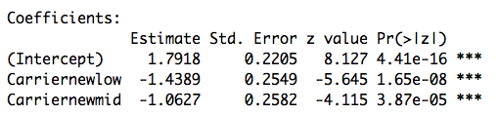

Table Model Fitting for EFRs~frequency on F-test

Based on the results of model fitting for EFRs~ frequency on F-test above, we conclude that these three levels all have significant effect on the accuracy of EFRs. The high frequency will lead to the highest accuracy of EFRs. The low frequency will lead to the lowest accuracy of EFRs.

|  |  |  |
| --- | --- | --- |
| level of frequency | Logit(pi) | pi |
| low | 0.3528 | 0.5872964 |
| mid | 0.7291 | 0.6746077 |
| high | 1.7918 | 0.8571478 |
| average | / | 0.70635 |

Table Values of pi of Frequency on F-test

Based on the table above, we can make sure that higher the frequency, the higher the accuracy. And the average accuracy is 0.70635.

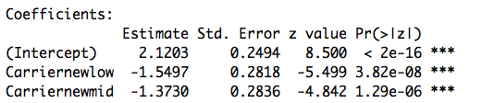

Table Model Fitting for EFRs~frequency on Rayleigh-test

Based on the results of model fitting for EFRs~ frequency on Rayleigh-test above, we also conclude that these three levels all have significant effect on the accuracy of EFRs based on the small p-values. The higher the frequency is, the higher the accuracy of EFRs will be.

|  |  |  |
| --- | --- | --- |
| level of frequency | Logit(pi) | pi |
| low | 0.5705 | 0.6388785 |
| mid | 0.7472 | 0.6785683 |
| high | 2.1203 | 0.8928606 |
| average | / | 0.7368 |

Table Values of pi of Frequency on Rayleigh-test

Based on the table above, we can make sure that higher the frequency, the higher the accuracy. And the average accuracy is 0.7368.

(3) Comparison

Comparing two testing methods, we find that the results are almost the same, I think it may be caused by the robustness of classification of frequency.

But the average of accuracy on Rayleigh-test is still a little bit higher than that on F-test.